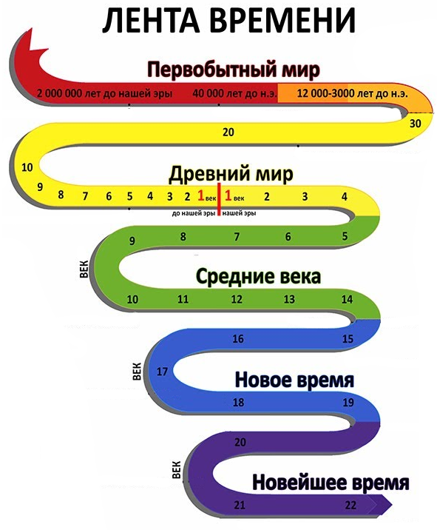

|  |  |
| --- | --- |
| **1)** | **2)** |
| **3)** | **4)**  **Picture background** |
| **5)** | **6)** |